Q1. Explain what Tableau is and why it is preferred over traditional spreadsheet tools for data analysis. Also mention any two industries where Tableau is commonly used and explain one use case.

Tableau is a powerful data visualization and business intelligence (BI) tool used to analyze, visualize, and share data in the form of interactive dashboards and reports. It helps users convert raw data into meaningful insights without requiring advanced programming knowledge.
Why Tableau is Preferred Over Traditional Spreadsheet Tools
Traditional spreadsheet tools like Microsoft Excel are useful for basic calculations and small datasets, but Tableau offers several advantages for modern data analysis:
- Interactive Visualizations
Tableau creates dynamic charts, graphs, maps, and dashboards that make data easier to understand and analyze.
- Handles Large Data Efficiently
It can process millions of rows of data much faster than spreadsheets.
- Real-Time Data Analysis
Tableau connects directly to databases and cloud platforms, allowing live data updates and real-time reporting.
- Easy Drag-and-Drop Interface
Users can create dashboards without complex coding, making it user-friendly.
- Better Decision Making
Visual insights help organizations quickly identify trends, patterns, and business opportunities.
Industries Where Tableau is Commonly Used
- Healthcare Industry
- Retail Industry
Example Use Case (Retail Industry)
Retail companies use Tableau to analyze customer purchasing behavior, sales trends, and inventory performance. For example, a supermarket chain can use Tableau dashboards to identify:
- Best-selling products
- Seasonal sales trends
- Store-wise performance
- Customer preferences
This helps the company improve inventory management, increase sales, and make better business decisions.

Q2. After connecting to the Sample – Superstore dataset: a) List the main types of fields available (examples: time-based, geographical, numerical). b) Identify any four Dimensions and any four Measures from the dataset. Hint: Look at the Data Pane on the left side of Tableau and observe blue (Dimensions) and green (Measures) fields.

After connecting to the Sample – Superstore dataset in Tableau, the following main types of fields are available in the Data Pane:
- Time-Based Fields
These fields contain date and time information.
Examples:
  - Order Date
  - Ship Date
- Geographical Fields
These fields represent locations and regions.
Examples:
  - Country
  - State
  - City
  - Region
  - Postal Code
- Numerical Fields
These fields contain numeric values used for calculations and analysis.
Examples:
  - Sales
  - Profit
  - Quantity
  - Discount
- Categorical/Text Fields
These fields contain names or categories.
Examples:
  - Category
  - Sub-Category
  - Segment
  - Customer Name

b) Four Dimensions and Four Measures
Dimensions (Blue Fields)
Dimensions are used to categorize and group data.
- Order ID
- Customer Name
- Category
- Region
Measures (Green Fields)
Measures are numerical values used for calculations and aggregation.
- Sales
- Profit
- Quantity
- Discount

Q3. Create a Bar Chart showing Total Sales by Category. Explain: Which field goes to Rows Which field goes to Columns Which aggregation is applied to Sales Hint: Drag Category and Sales into the view and observe Tableau’s default behaviour.

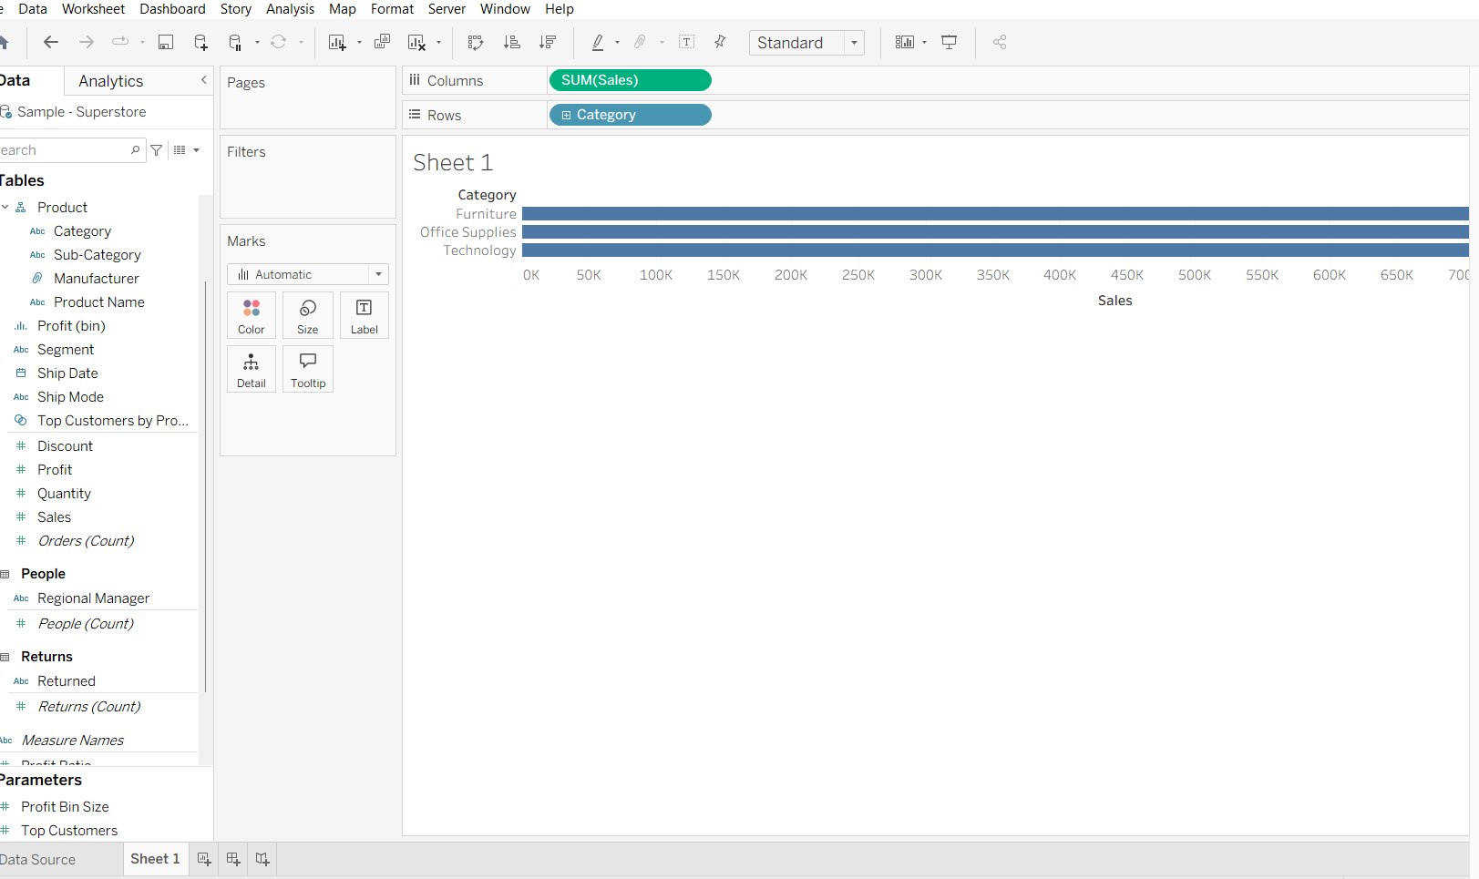
Which field goes to Rows?
Category goes to the Rows shelf.
This creates separate categories such as:
Furniture
Office Supplies
Technology
Which field goes to Columns?
Sales goes to the Columns shelf.
This displays the sales values horizontally as bars.
Which aggregation is applied to Sales?
Tableau automatically applies the SUM aggregation to Sales.
So the chart shows:
SUM(Sales) by Category
This means Tableau adds all sales values together for each category to calculate the total sales.

Q4. What insight can be gained by comparing Sales and Profit together? Then explain how you would create a chart to analyze Profit by Sub-Category. Hint: Use Sub-Category as a Dimension and Profit as a Measure.

In Tableau, comparing Sales and Profit helps identify whether high sales are actually generating good profit.
Insights That Can Be Gained
A product or category may have high sales but low profit, which could indicate:
Heavy discounts
High costs
Poor pricing strategy
A category with lower sales but high profit may be more valuable to the business.
This comparison helps businesses:
Improve pricing decisions
Identify loss-making products
Focus on profitable categories and sub-categories
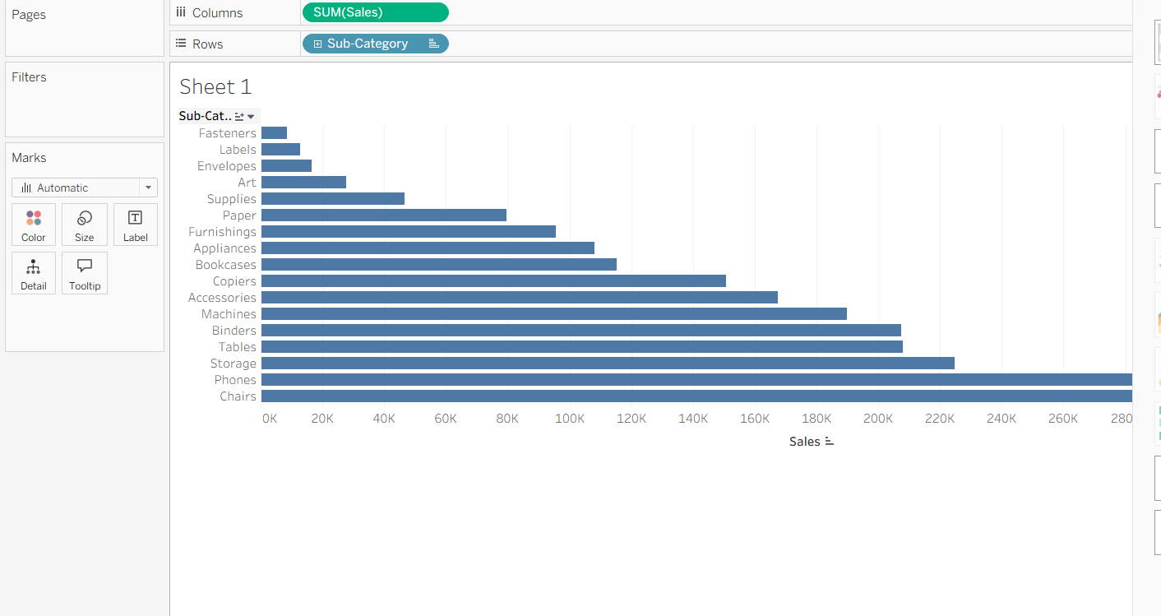

Result
The chart will display:
Which sub-categories generate the highest profit
Which sub-categories are causing losses
Example insights:
Copiers may show high profit
Tables may show negative profit
This helps companies identify the most and least profitable product areas.

Q5. Create a Line Chart to show Sales Trend over Order Date. Which date level would you choose (Year / Quarter / Month)? Why are line charts suitable for time-based analysis? Hint: Drag Order Date and change its date hierarchy from Year to Month if needed.

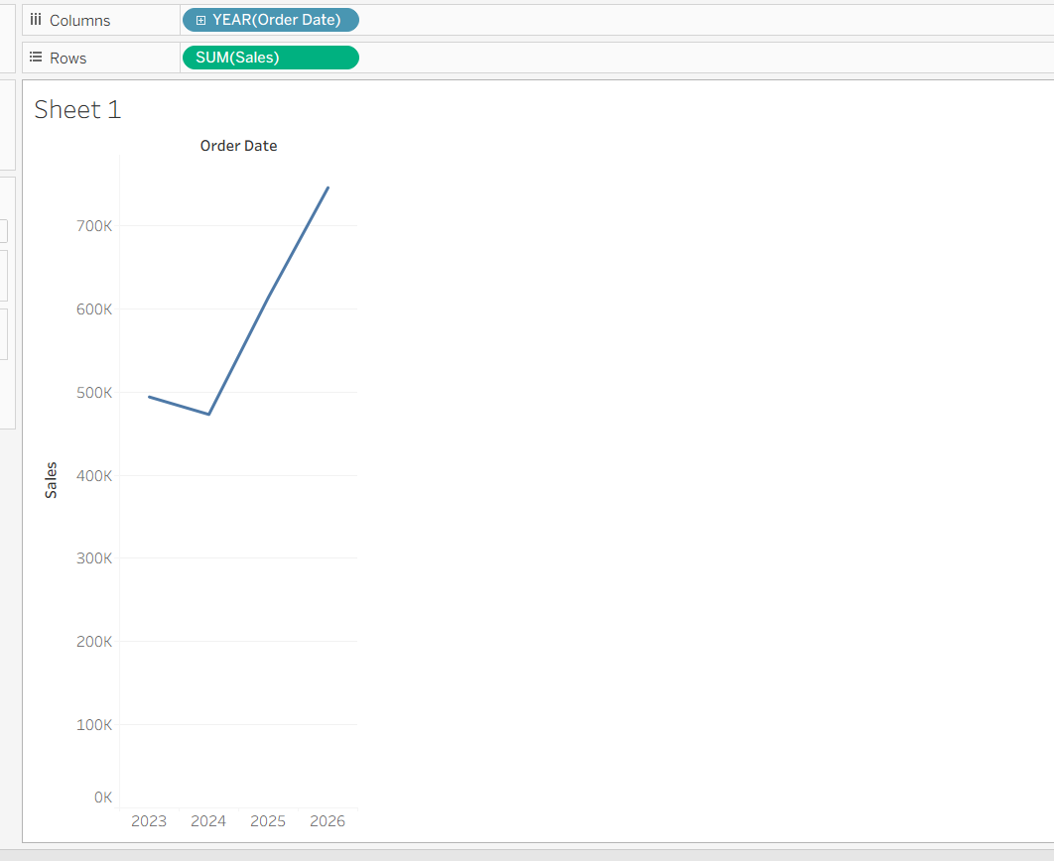

I would choose the Month level.
Why?
Monthly analysis gives a more detailed view of sales trends.
It helps identify:
Seasonal patterns
Monthly growth or decline
Peak sales periods
Business performance over time
Using only Year may hide important monthly variations, while Quarter provides less detail than Month.

Why Are Line Charts Suitable for Time-Based Analysis?
Line charts are best for time-based data because they:
Show Trends Clearly
They display increases and decreases over time in a smooth and easy-to-understand way.
Help Identify Patterns
Users can easily spot:
Seasonal trends
Sudden spikes or drops
Long-term growth
Allow Continuous Comparison
Time flows continuously, and line charts effectively connect data points across dates.

Result
The chart will display how Sales change over time by Month, helping businesses analyze performance trends and make better decisions.

Q6. Apply a Basic Filter to display data only for: Region = “West” Category = “Technology” Explain the steps and mention which shelf is used. Hint: Drag the required fields to the Filters shelf and select appropriate values.

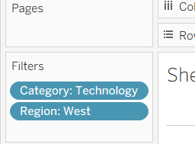
After applying both filters:
- Only data from the West Region
- And only records from the Technology Category
will be displayed in the worksheet and visuals.
This helps users focus analysis on a specific region and product category.

Q7. Explain the business importance of geographical analysis. Then describe how you would create a Map showing Sales by State using Sample – Superstore. Hint: Use State and Sales. Tableau automatically detects geographic fields.
Business Importance of Geographical Analysis
Geographical analysis is important in business because it helps organizations understand performance across different locations such as states, cities, or regions.
In Tableau, geographical analysis helps businesses:
- Identify High and Low Sales Areas
Companies can see which states or regions generate the most revenue.
- Improve Decision Making
Businesses can plan marketing, inventory, and expansion strategies based on regional performance.
- Understand Customer Trends
Different locations may have different customer preferences and buying patterns.
- Optimize Resource Allocation
Companies can focus resources on profitable areas and improve weaker regions.

How to Create a Map Showing Sales by State
Using the Sample – Superstore dataset:
Steps
- Open a new worksheet.
- Drag State from the Data Pane into the view area.
  - Tableau automatically recognizes it as a geographic field.
  - A map will be created automatically.
- Drag Sales onto:
  - Colour on the Marks card
or
  - Size on the Marks card
- Tableau will display sales values for each state using colors or bubble sizes.
Fields Used
- State → Geographic Dimension
- Sales → Measure
Result
The map will show:
- States with higher sales in darker/larger marks
- States with lower sales in lighter/smaller marks
This visualization helps businesses quickly compare sales performance across locations.
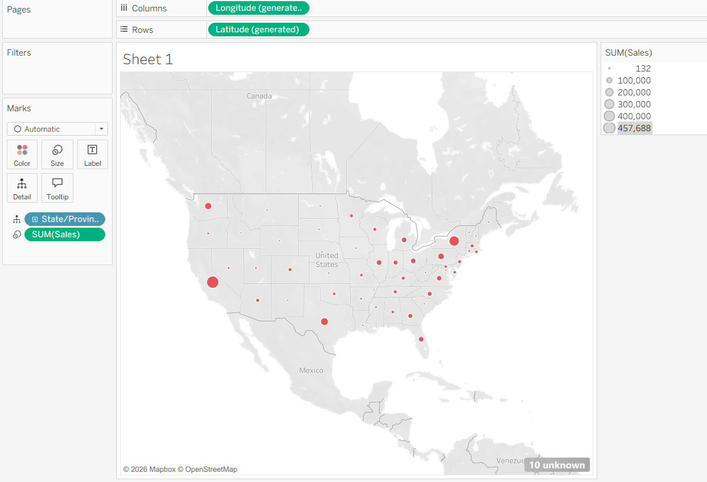

Q8. What is the difference between a Worksheet and a Dashboard in Tableau? Why is a dashboard more useful for decision-makers?

Worksheet | Dashboard
A worksheet is a single visualization or chart created from data. | A dashboard is a collection of multiple worksheets displayed on one screen.
It is used to analyze one aspect of the data at a time. | It is used to analyze multiple aspects of the data simultaneously.
Contains one view such as a bar chart, line chart, map, or table. | Contains multiple views, charts, filters, legends, and interactive elements.
Primarily used for detailed data exploration and analysis. | Primarily used for monitoring, reporting, and decision-making.

Why is a Dashboard More Useful for Decision-Makers
A dashboard provides a complete overview of key business information in a single view, making it easier for decision-makers to understand performance quickly. It combines multiple visualizations, allowing users to compare trends, identify patterns, monitor KPIs, and make informed decisions without switching between different worksheets. Interactive filters and drill-down capabilities further help decision-makers explore data efficiently and gain actionable insights.
Example: A sales dashboard can display Sales, Profit, Region-wise Performance, and Product Category Analysis together, enabling managers to evaluate overall business performance at a glance.

Q9. What is Tableau Prep, and why is it important in real-world data projects? What is Tableau Prep, and why is it important in real-world data projects?
Then explain how you would: Remove null values Remove duplicate records Change incorrect data types (Answer in steps, no tool access required.)

Tableau Prep is a data preparation tool developed by Tableau Prep that helps users clean, combine, reshape, and organize data before analysing it in Tableau. It provides a visual and user-friendly interface for performing data preparation tasks without requiring advanced programming skills.
Importance of Tableau Prep in Real-World Data Projects
- Data Cleaning
  - Removes errors, duplicates, and missing values.
  - Ensures data accuracy and consistency.
- Data Combining
  - Allows users to join, union, and merge data from multiple sources.
  - Creates a unified dataset for analysis.
- Improves Data Quality
  - High-quality data leads to more reliable reports and better business decisions.
- Saves Time
  - Automates repetitive data preparation tasks through reusable flows.
  - Reduces manual effort and increases productivity.
- Visual Workflow
  - Users can see each step of the data preparation process, making it easier to understand and troubleshoot.
- Supports Better Analysis
  - Clean and structured data improves the effectiveness of dashboards and visualizations in Tableau.
Conclusion
Tableau Prep is an essential tool in real-world data projects because it helps transform raw, messy data into a clean and analysis-ready format. By improving data quality and streamlining preparation tasks, it enables organizations to create accurate reports and make informed business decisions more efficiently.
A. Remove Null Values
Steps:
- Open Tableau Prep and connect to the data source.
- Add a Clean Step to the flow.
- Identify fields containing Null values.
- Click the profile card of the field.
- Select the Null value and choose Exclude to remove those records.
- Verify that the null records are no longer present in the data preview.

B. Remove Duplicate Records
Steps:
- Connect to the dataset in Tableau Prep.
- Add a Clean Step.
- Identify the fields that uniquely define each record (e.g., Order ID, Customer ID).
- Add an Aggregate Step if required.
- Group by the unique identifier fields.
- Keep one occurrence of each record and remove repeated entries.
- Review the output to ensure duplicate records have been eliminated.

C. Change Incorrect Data Types
Steps:
- Open the dataset in Tableau Prep.
- Locate the field with the incorrect data type.
- Click the data type icon beside the field name.
- Select the correct data type:
  - String (Text)
  - Number (Integer/Decimal)
  - Date
  - Date & Time
  - Boolean
- Verify the values are displayed correctly after conversion.
- Check for any errors or invalid values and correct them if necessary.

Importance
These data-cleaning steps help improve data quality, accuracy, and consistency, ensuring that the final analysis and dashboards provide reliable insights for decision-making.

Q10. A retail manager wants answers to the following: Which category generates the highest profit? Which region performs poorly? How does sales change over time? a) Mention which charts you would use b) Identify one key insight that management could derive c) Explain how this helps in business decision-making

- Which category generates the highest profit?
- Which region performs poorly?
- How does sales change over time?
a) Mention which charts you would use
Business Question | Recommended Chart
Which category generates the highest profit? | Bar Chart (Category vs Profit)
Which region performs poorly? | Bar Chart or Map Chart (Region vs Profit/Sales)
How does sales change over time? | Line Chart (Order Date vs Sales)

b) Identify one key insight that management could derive
Management may discover that:
- The Technology category generates the highest profit.
- The South region has the lowest sales and profit performance.
- Sales increase significantly during festive or holiday seasons and decline during off-peak periods.
(The actual insight depends on the dataset being analysed.)
c) Explain how this helps in business decision-making
- Category Analysis
  - Helps management focus on the most profitable product categories.
  - Supports decisions related to inventory, pricing, and marketing investments.
- Regional Performance Analysis
  - Identifies underperforming regions.
  - Enables managers to take corrective actions such as promotions, staff training, or market expansion strategies.
- Sales Trend Analysis
  - Helps forecast future demand.
  - Assists in planning inventory levels, budgeting, and seasonal marketing campaigns.
Conclusion
Using a Bar Chart for profit by category, a Bar/Map Chart for regional performance, and a Line Chart for sales trends allows management to quickly identify profitable areas, address weak-performing regions, and plan future business strategies based on sales patterns.

